MongoDB Assignment

Question 6}

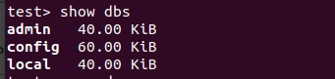

Question 7}



Question 8}



Question 9}

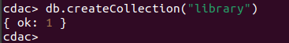

Question 10}
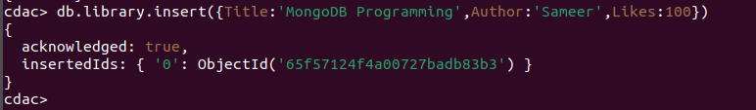
Question 11}



Question 12}

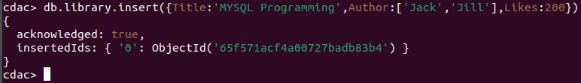

Question 13}

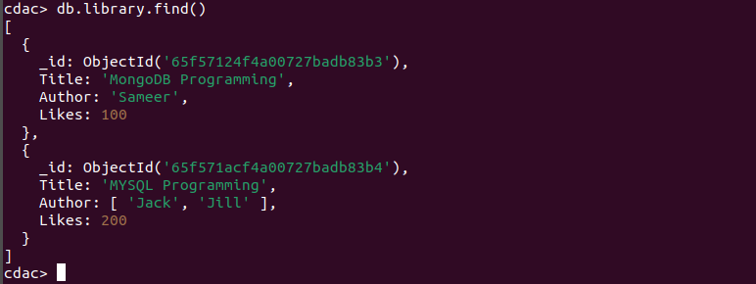

Question 14}

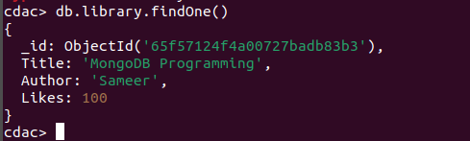

Question 15}

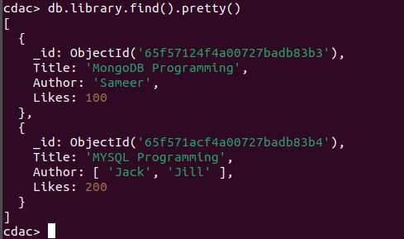

Question 16}

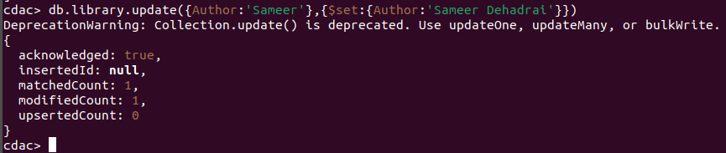
Question 17}

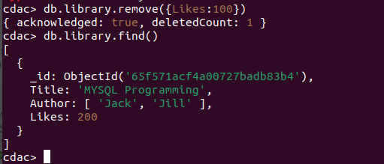

Question 18}



Question 19}



Question 20}
Question 21}


